Now 4.2 version – health care release version notes , 10 pages

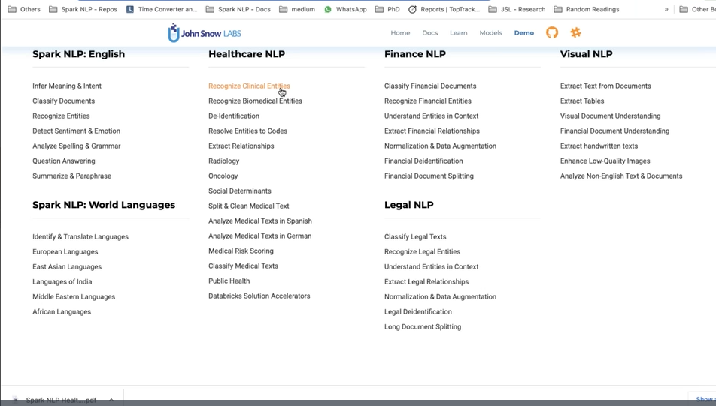

814 clinical or health care models

Most of them English

Total 8 languages its supports

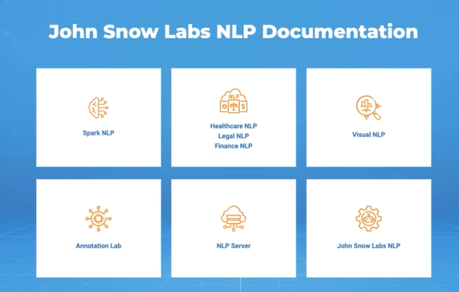

Spark Nlp- on top of apache spark, spark nlp

Output of one annotator- input of other annotator

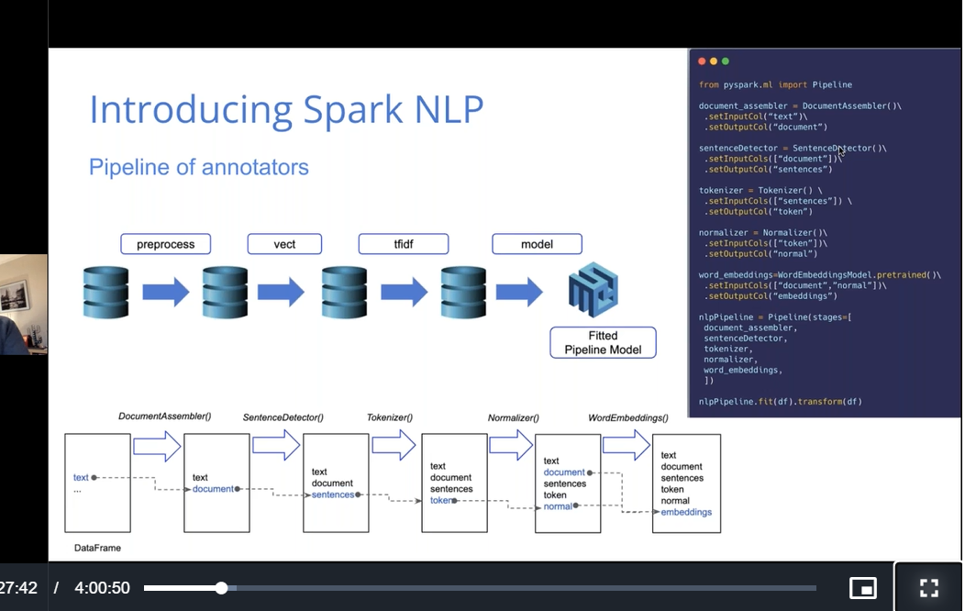

Light pipeline concept: huge data

* Its very fast since its just taking string not rdd or spark dataframe

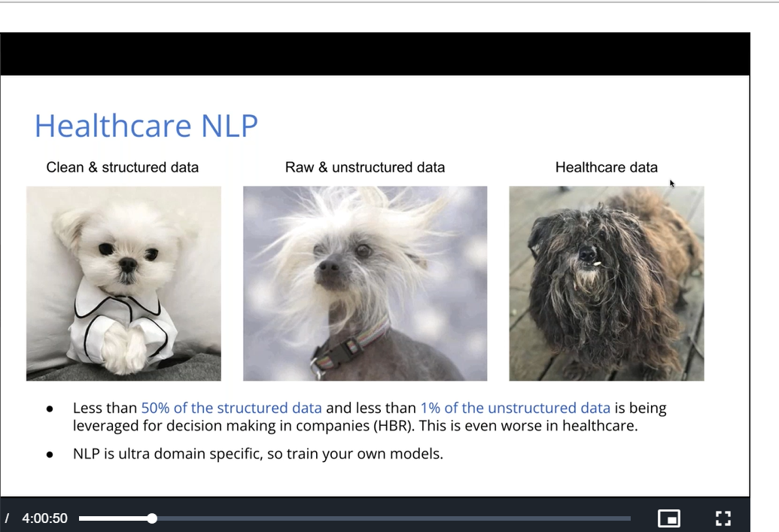

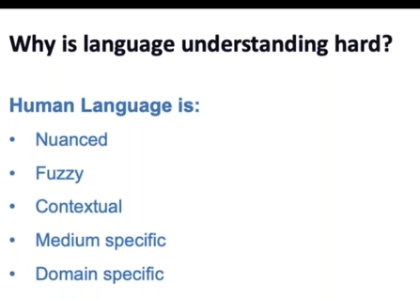

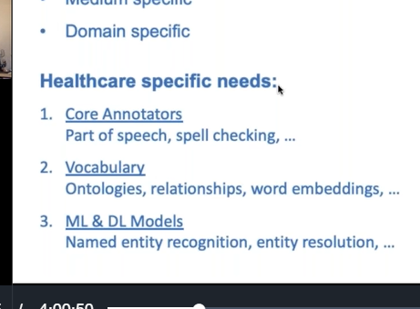

Most of them are copy pasted templates in medical data

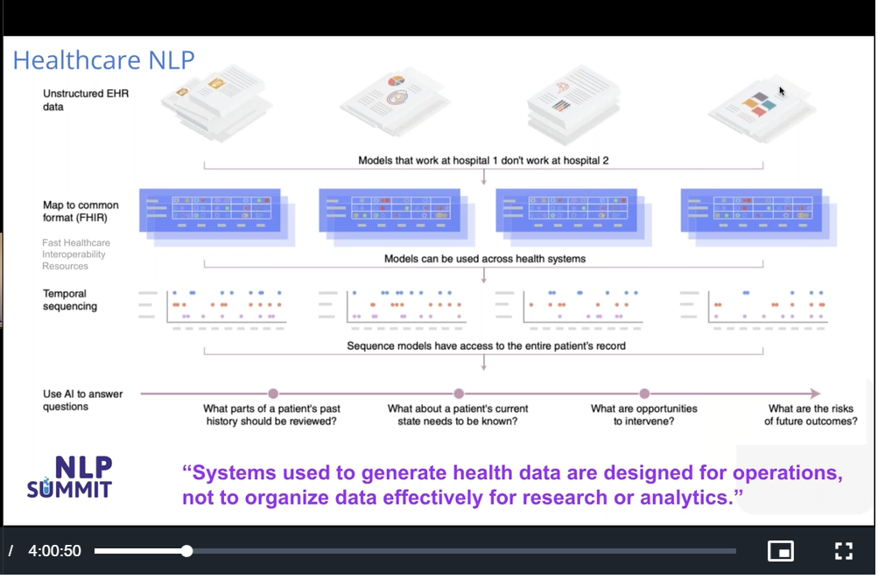

Unstructured healthcare data(electronic health records- lab records, ecg)- mapped to known format-(common format)

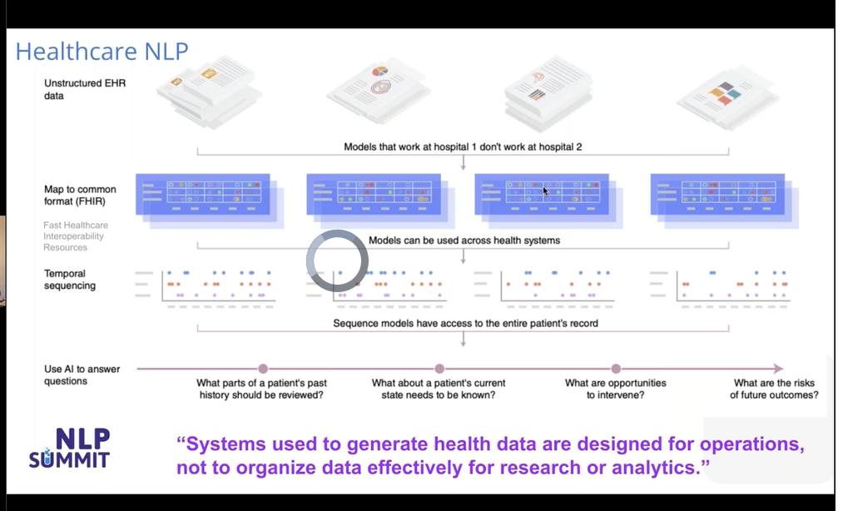

Most common format of health records-fhir- fast healthcare interoperability rehouses

Timeline of patients records

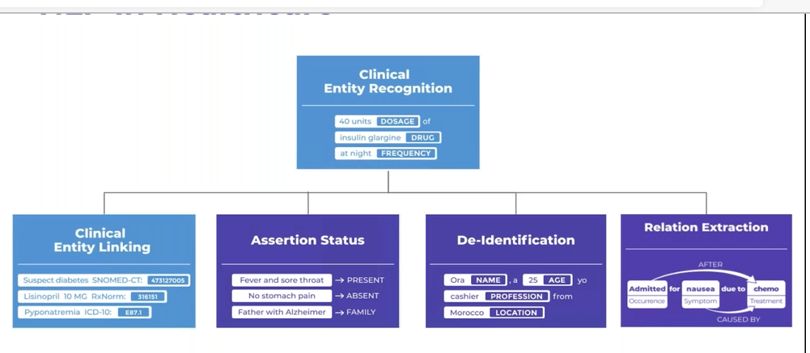

Clinical entity recog- ner

Meaning full chunk of annotators

--

Name of patients

Drug and dosage relation can be find used ner

Assertion also through ner

Patient name- de identification

Clinical entity linking: drug and dosage

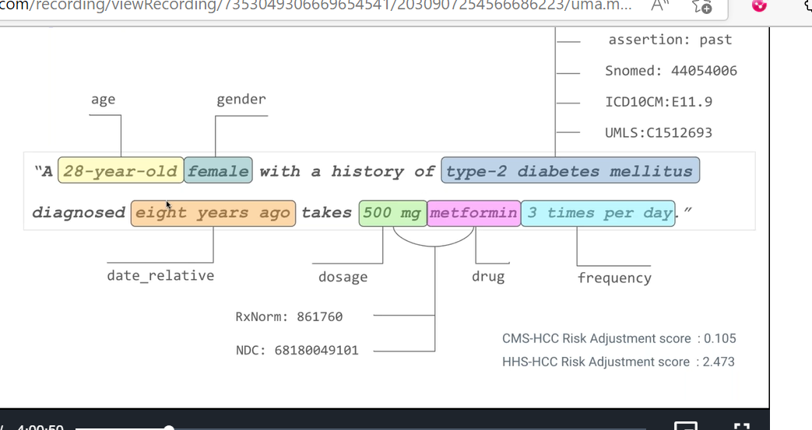

One model can generate this output

Used 15 diff annotators

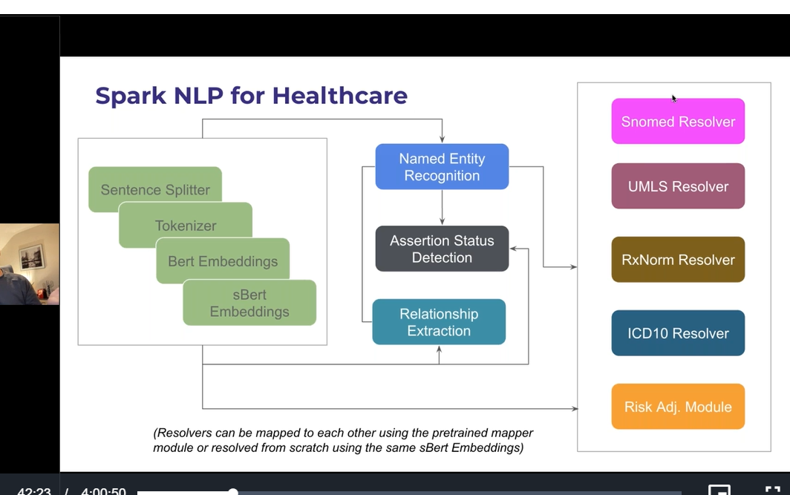

When I want to recognize: NER

Document assembler

Sentence splitter

Tokenization

Embeddings

NER

--

Knowledge graph can be generated

Help to write queries to get specific info

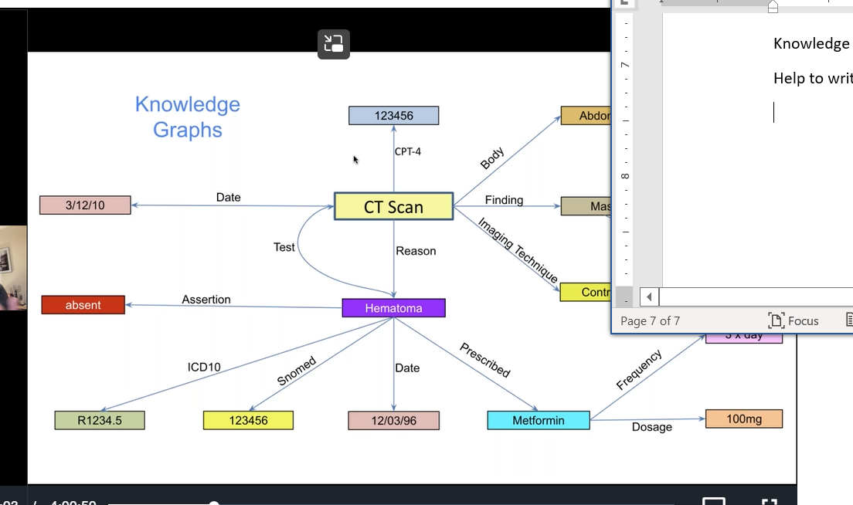

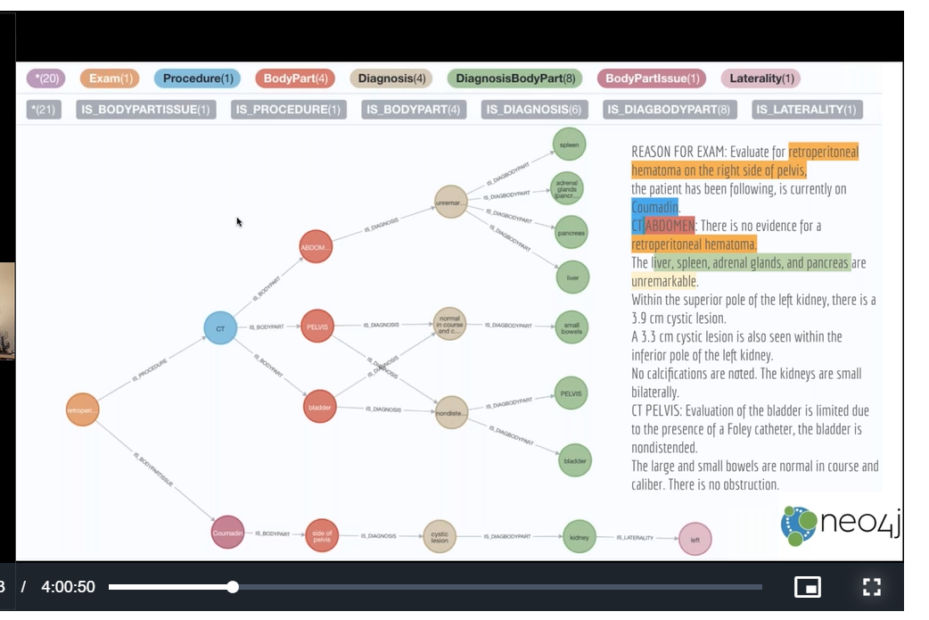

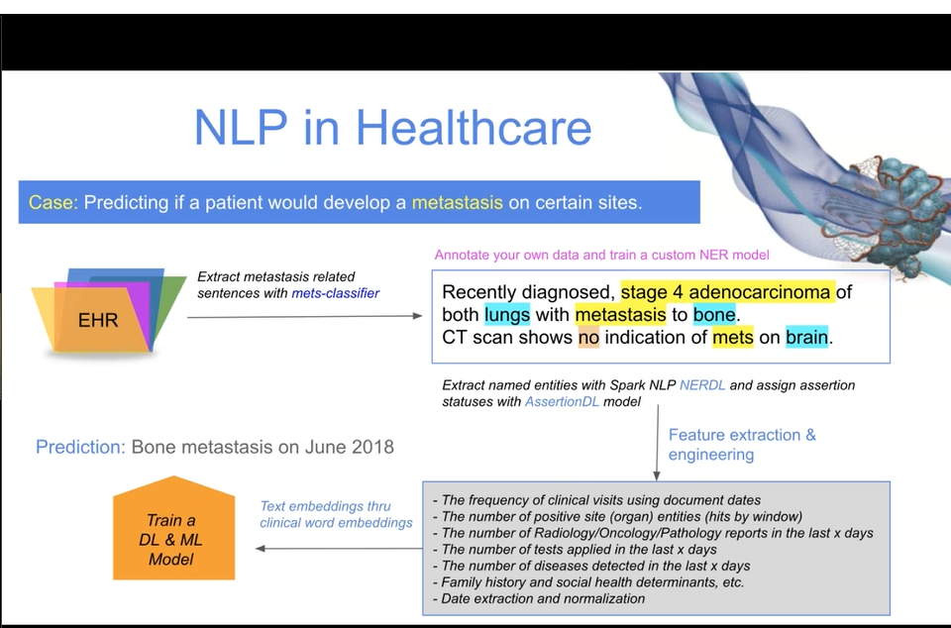

If a patient has lung cancer visiting hospital for 5 years?

1000 reports generated in 5 years

We can recognize

--

Nlp more automation than deep learning

Rule based ner models, rule based annotators

--

Document assembler: takes text column

It’s a gate way

It generates document

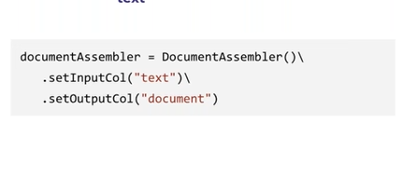

Sentesedetector:

DL based

Rule based

Dl based: any character at the end of line

Rule based : own advantage, specific

Takes document

Generate sentese

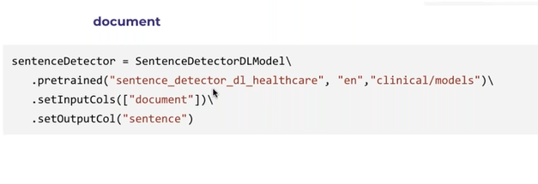

Tokenizer: sentence to tokens

We can skip sentences when we don’t use ner

Or relation extraction

But in healthcare we mostly do ner and relation extraction… so its mandatory to convert doc to sentence

--

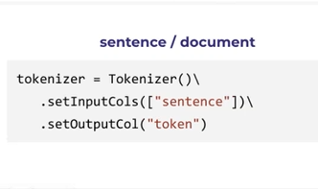

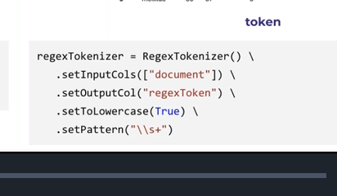

Regex: when we want to write own cases

Camel case situations

--

Word embeddings:

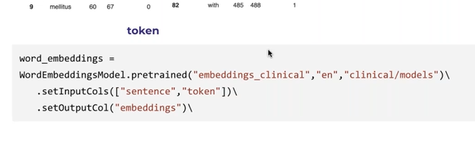

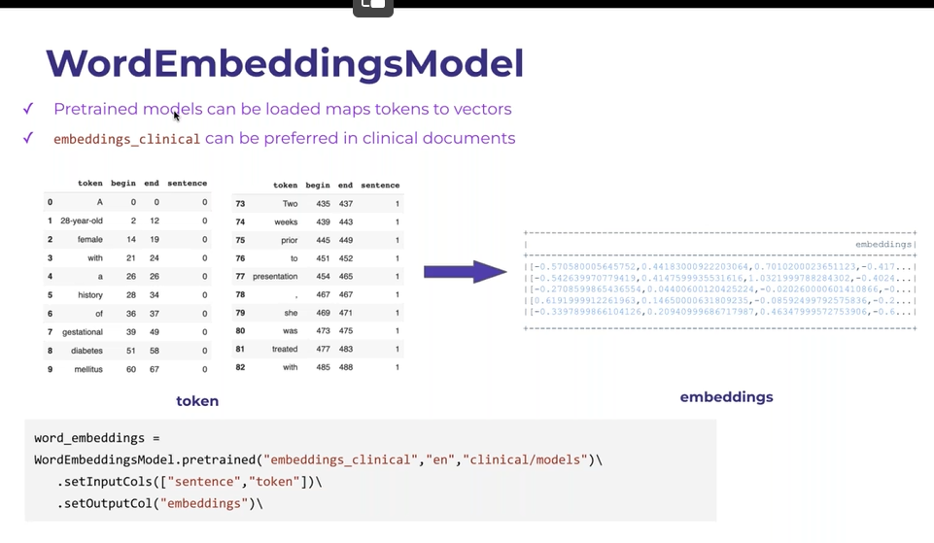

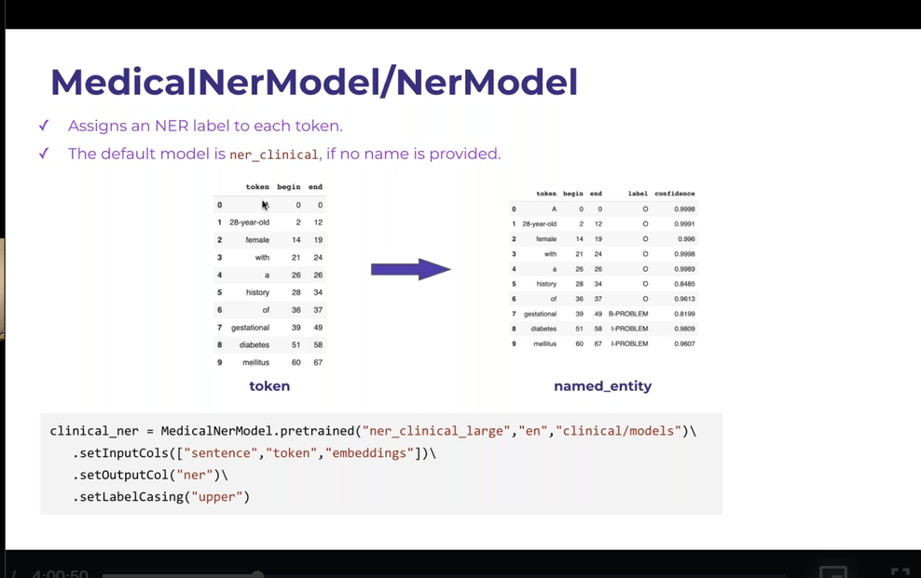

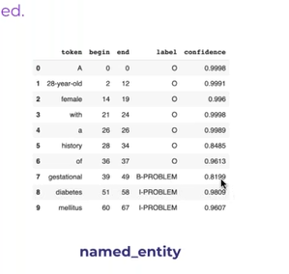

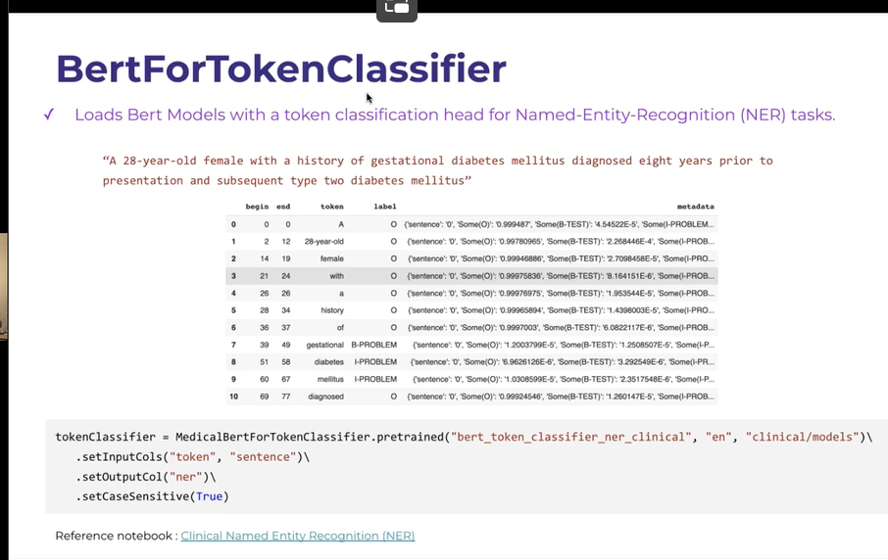

Bert:

More accuracy; bert but slow, computational expensive than glove

Instead of going for 4 ner models its better to go bert

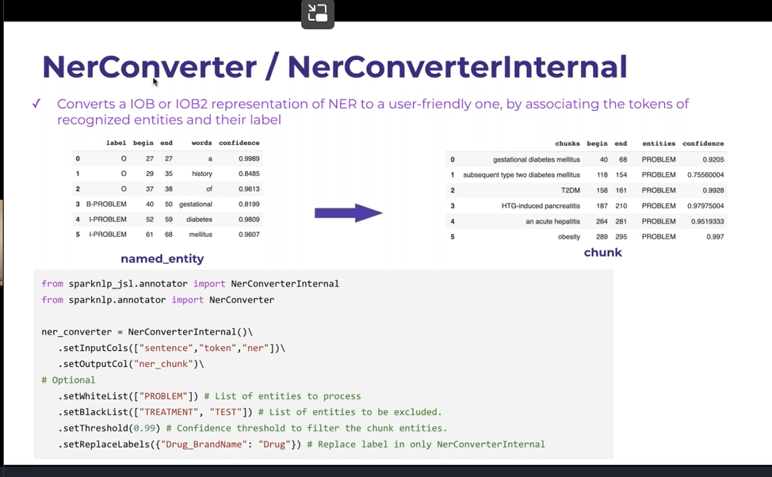

Job: ith text into proper phrases

Now we havener chunck

..

Now chunk mergers: combind multiple chunks together

When we want to use 2 different ner models, which generates 2 ner convertors- 2 ner chunks,

Chunk mergers ; generate one out of 2 ner chuncks produced by 2 ner models

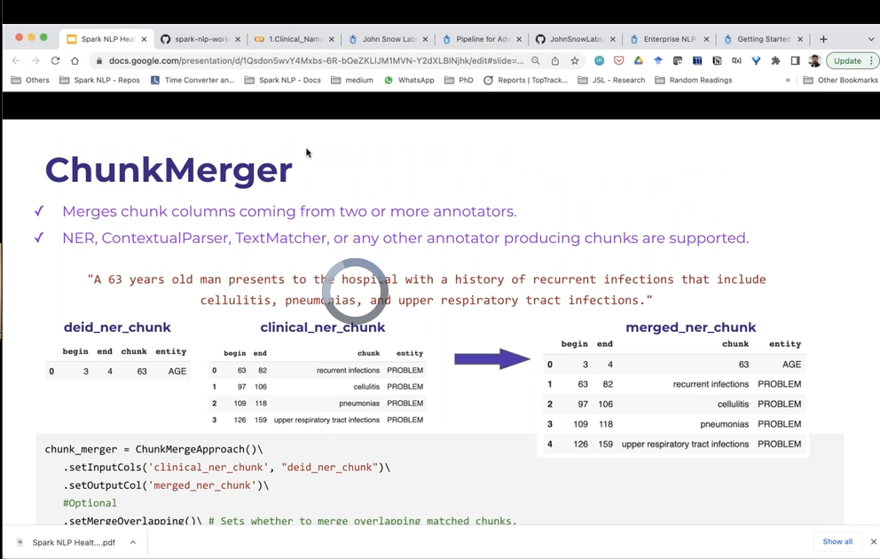

NER MODELS:

Lstm

Bert

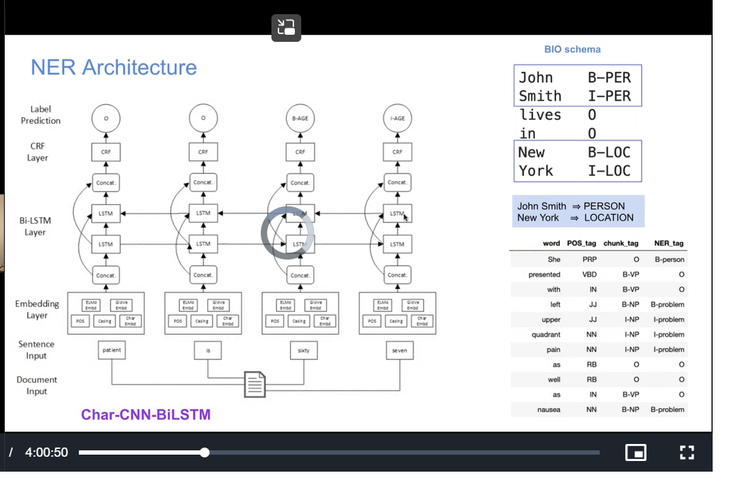

Char cnn bilstm: highly powerful

We need to find right entity

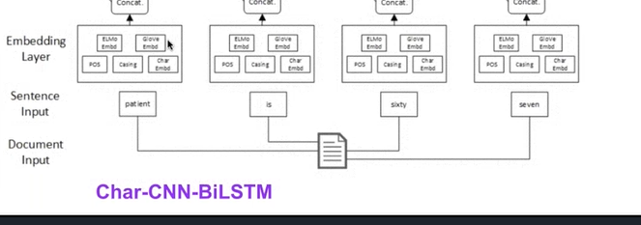

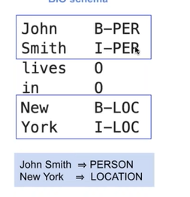

B – beginning of person entity

I – inside of person entity

B: starting with different case either capital or small or upper or lower case

Some languages : its starts with lower case

o- others, not patient

below is conll dataset

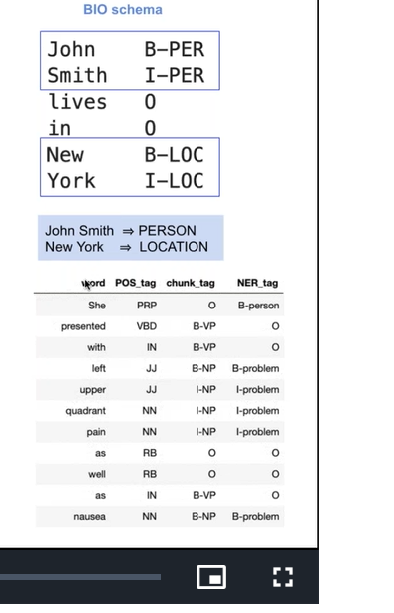

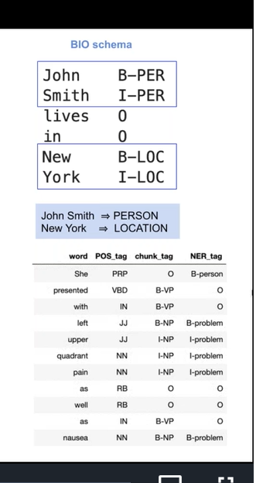

We map tokens to labels

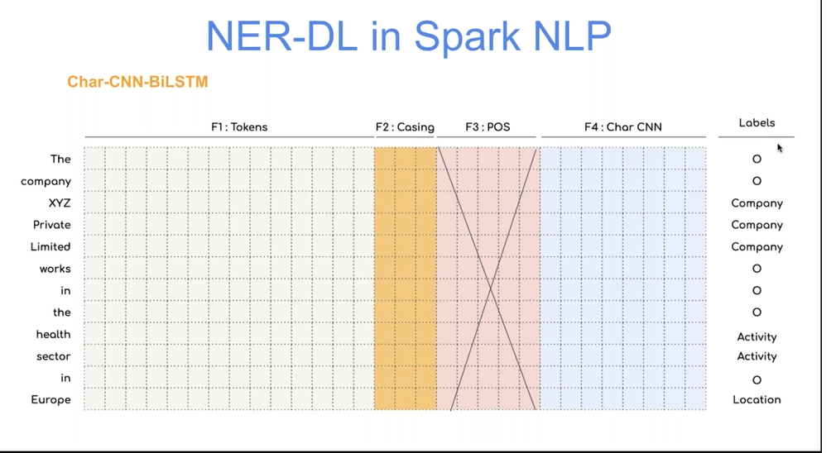

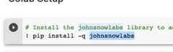

We get all secret keys

--

Medical.ner models

We need to use in pipelines

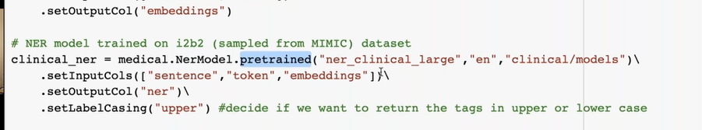

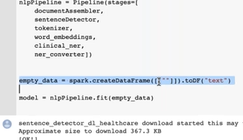

Fitting on empty dataset

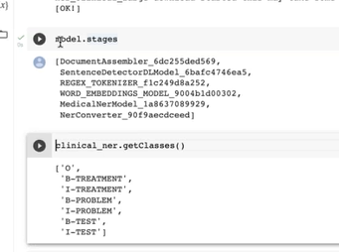

I can also check classes of ner model

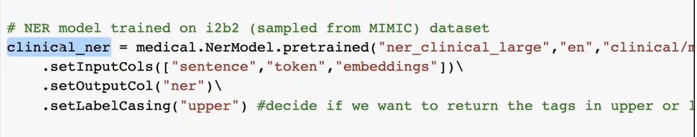

To know all embedding

Because while working on test data

We used to convert to that embeddings

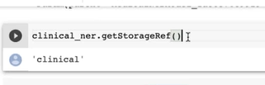

Now download sample data

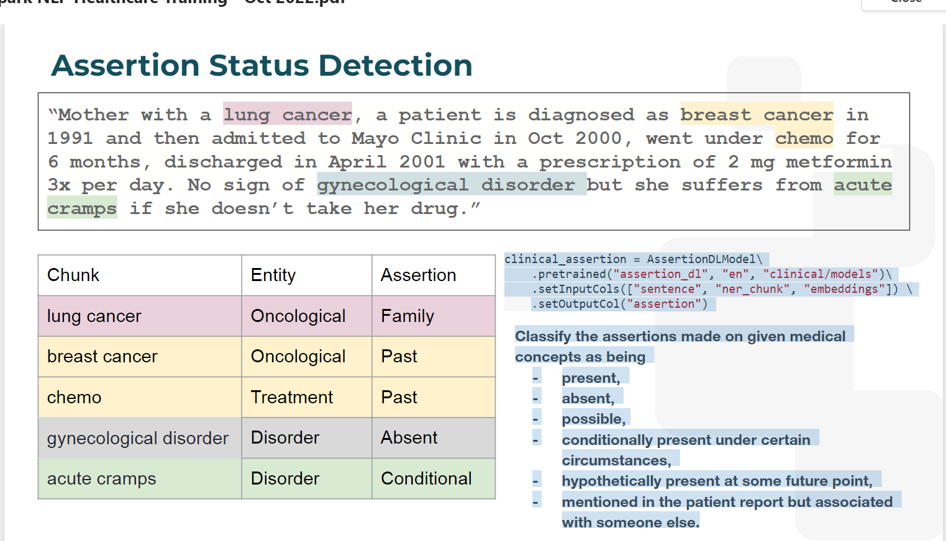

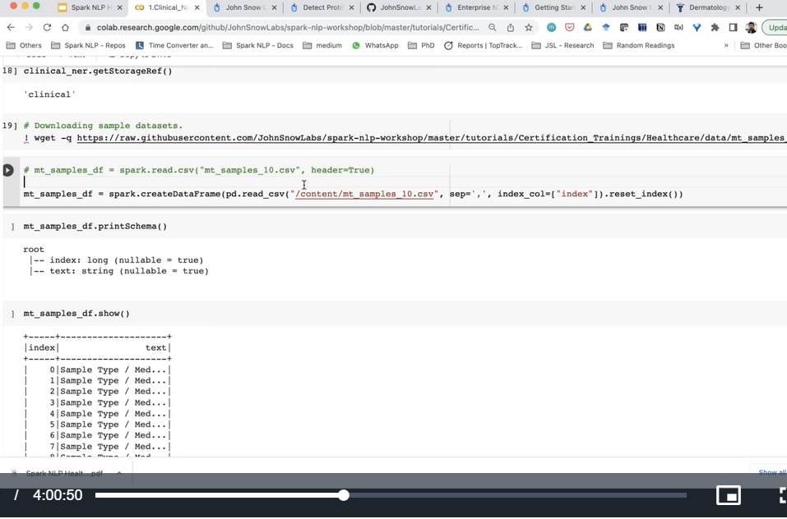

Convert to spark nlp

Reading one record of text

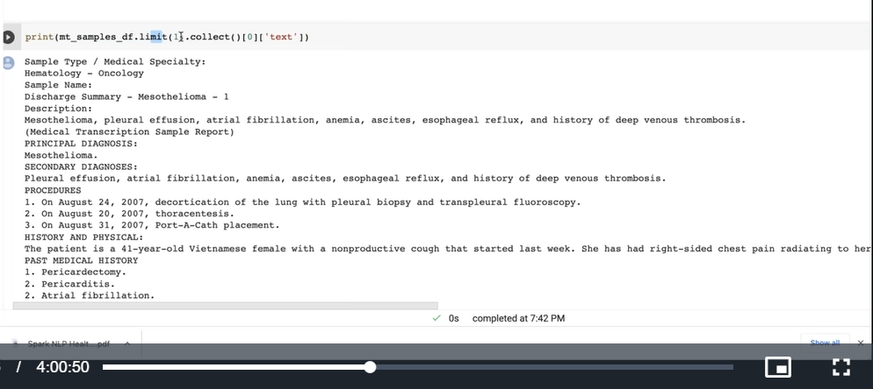

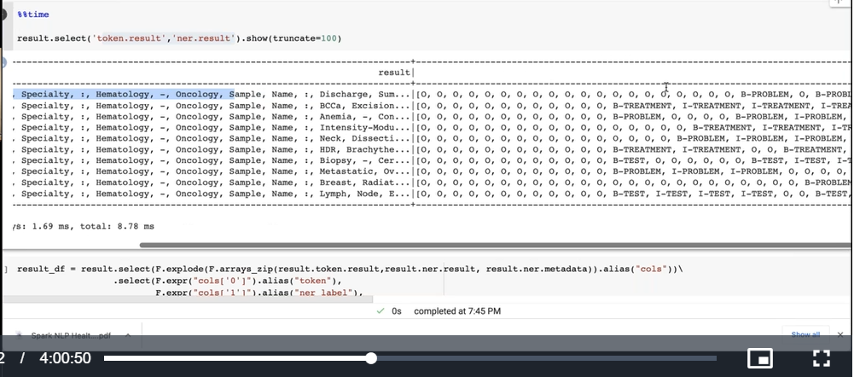

List of tokens left

List of ner in right side

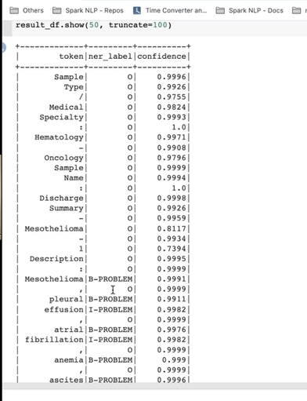

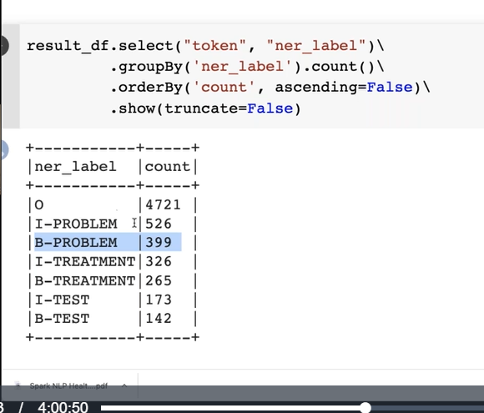

In this model we have

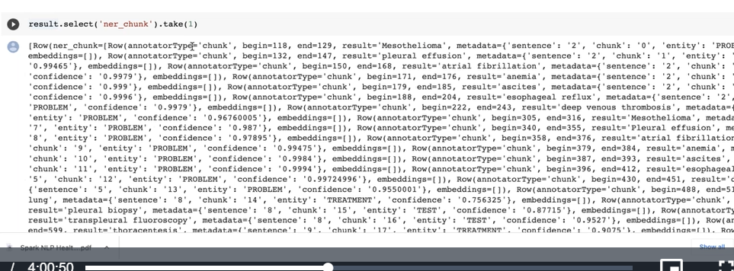

What is ner chunck

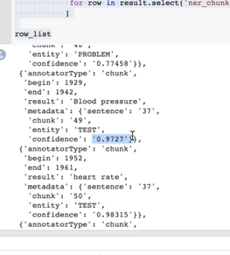

Lightpipeline: small data

Rather than dataframe approach of spark

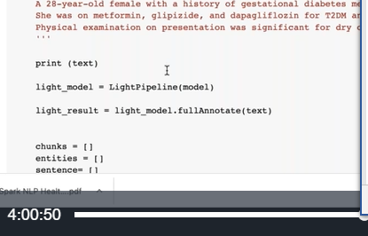

Previously we used below to transform the model to real data

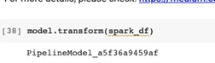

Light model has 2 approaches:

Annotate

Full annotate : which give all the info incl metadata

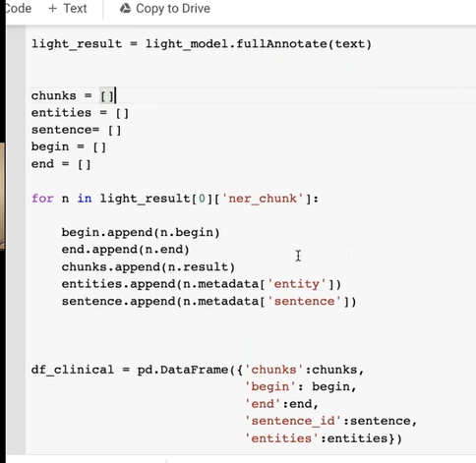

Created to dataframe

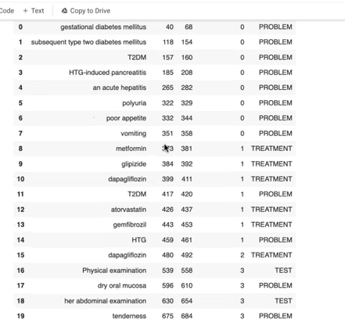

We can save it as csv

Full annotator results dictionary

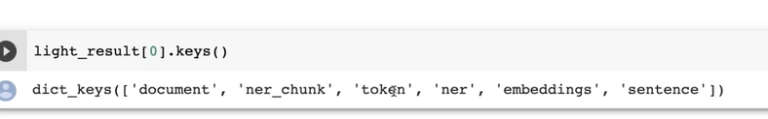

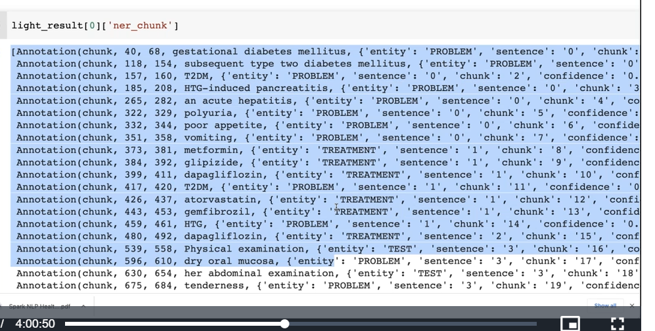

When we don’t want all metadata

Go for annotate instead of full annotate

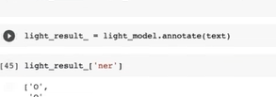

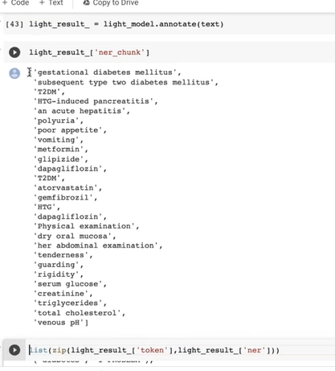

We cant see type of ner in just annotate model as type is related to metadata can be seen in full annotate

What if we want to get embedding?

Too heavy

That’s why we don’t print

We can see embedding with below code

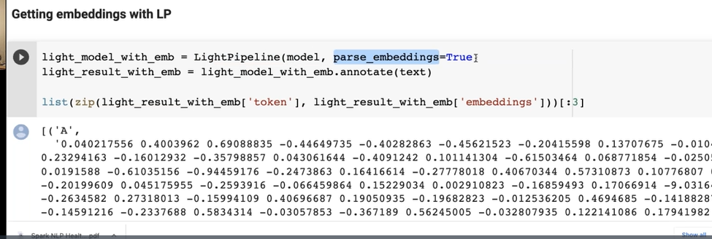

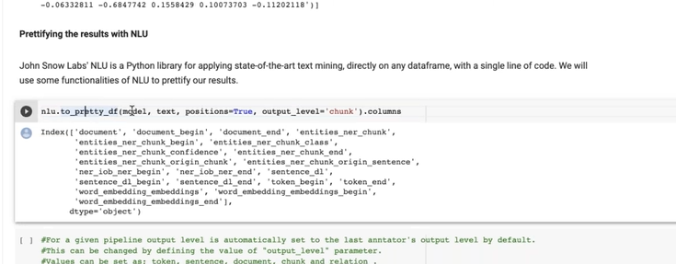

In nlu, to_pretty-df

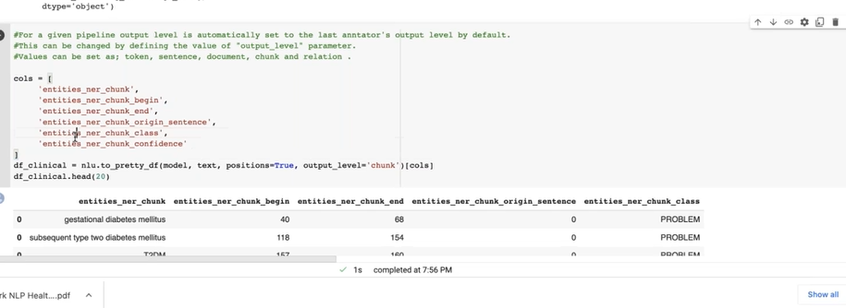

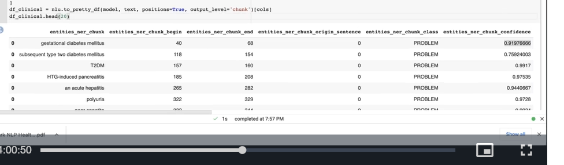

For this we need only a pipeline and a text

That’s all

Now visualize:

Viz in john snow

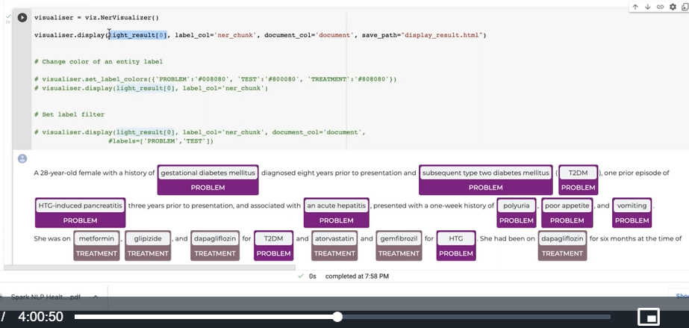

Lable col: which one to visualize

We can change colour

--

Ner jsl

It returns more than 80 entities

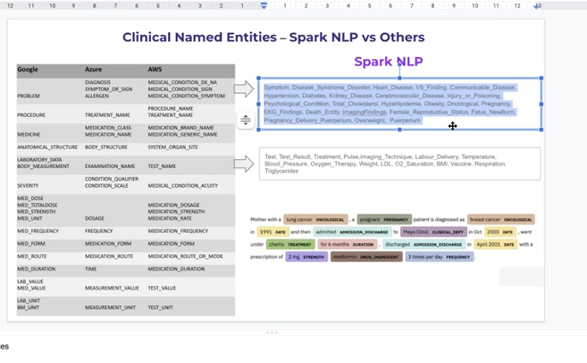

Others has only 20

We are not also saying problem

But also what kind of problem

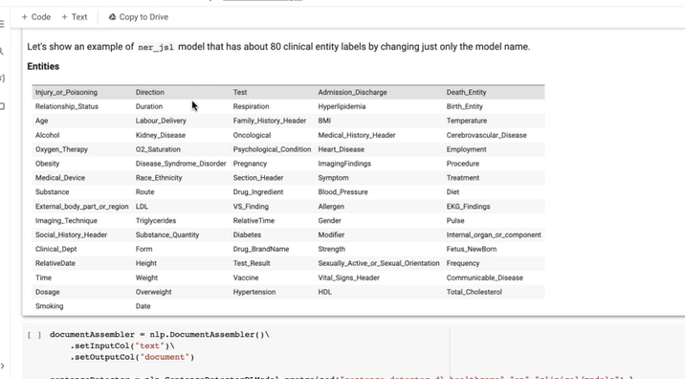

Same pipeline

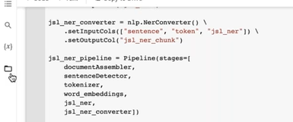

Ner model changed to jsl

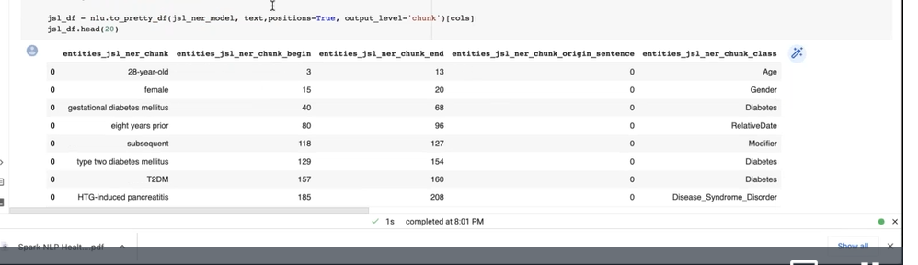

In ner-jsr – age also entity

Also disease classification- diabatic

Whereas ner large : it only recognize as problem

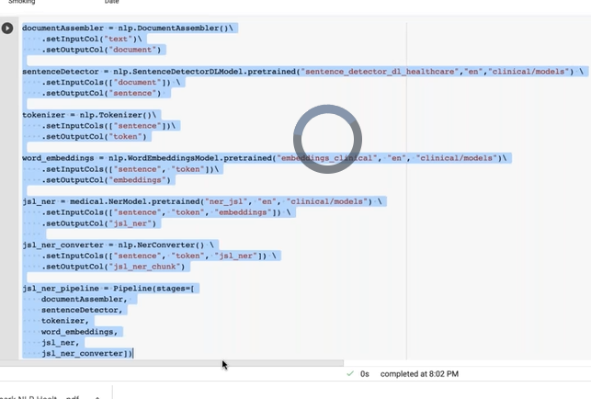

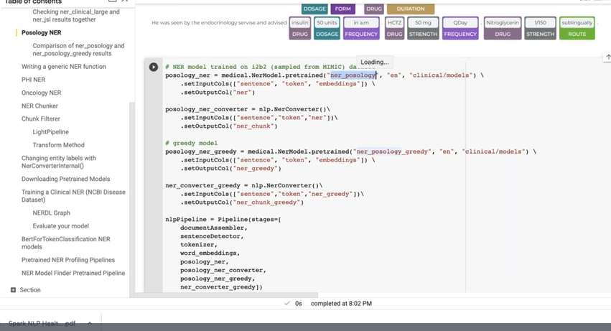

Pipeline same

Model changes

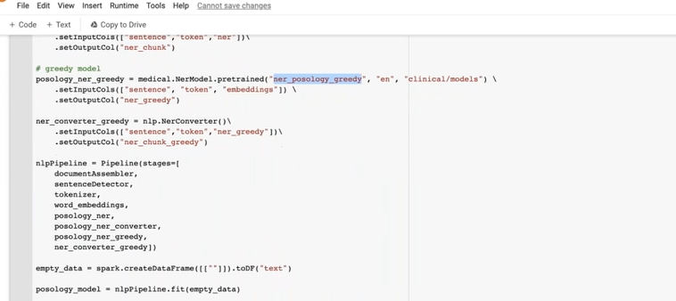

2 models

Posology- medication

Ner_posology

Ner-posology_greedy

Labels

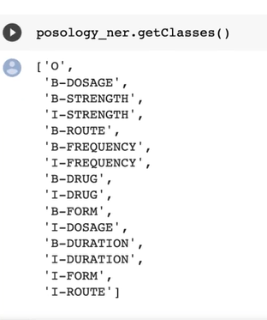

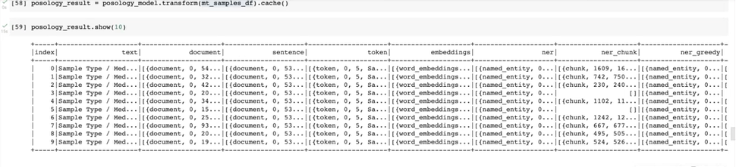

Result=

In normal posology: drug and dosage(strength) separate entities

Where as posoloy_greedy(t=drug and dosage same entity)

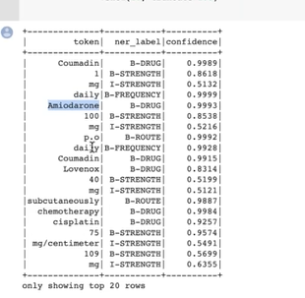

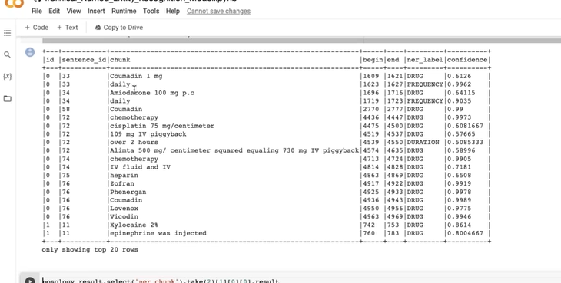

We can write generic ner function

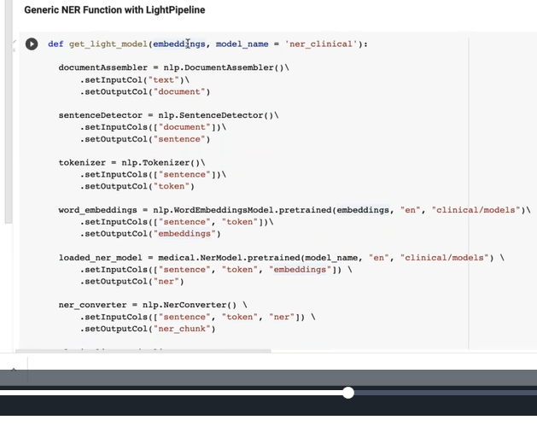

It takes embeddings and model name as parameters

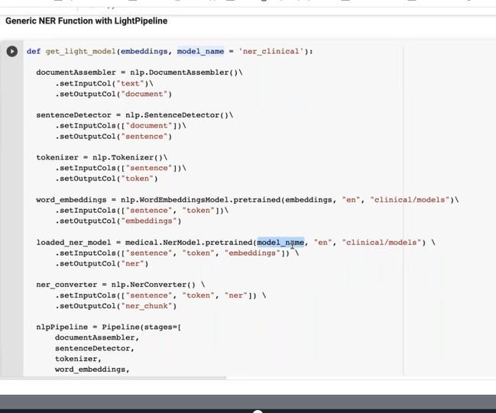

We can use any model and embeddings which we want

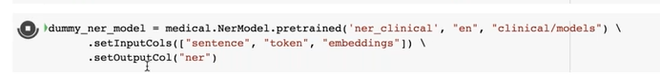

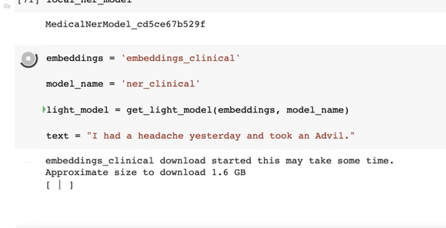

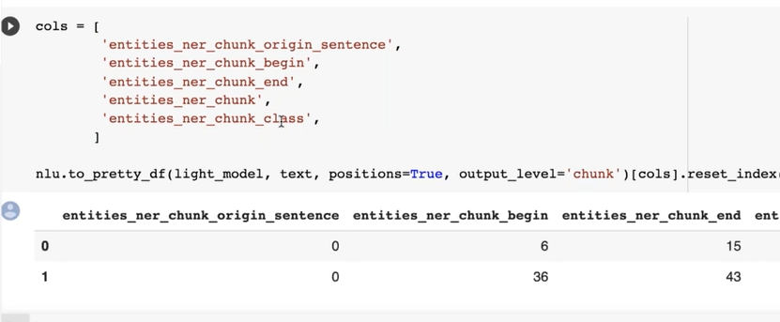

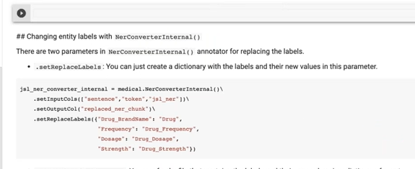

Grredy: can merge two entities

To rename entity labels: nerconverter

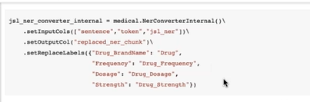

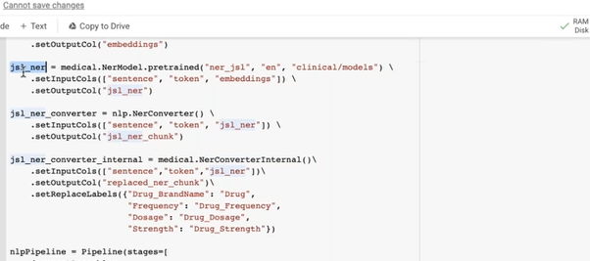

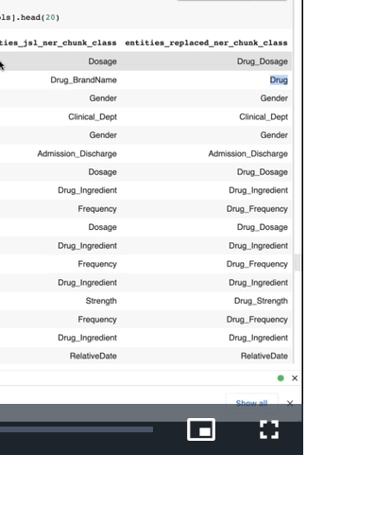

U can observe changes

--

--

Download models

We can go to model hub

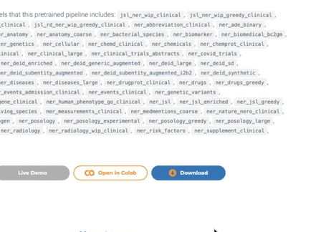

When u clink on download button it copies link

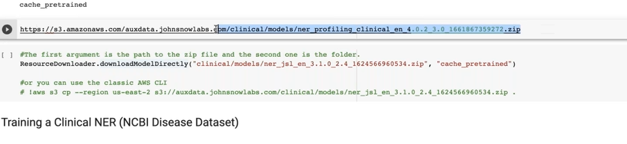

Highlighted is model

Load that into ner model

Conll format

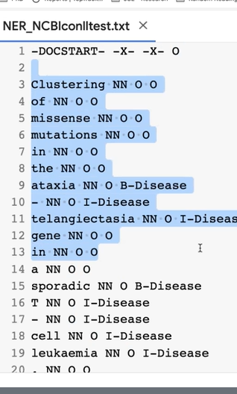

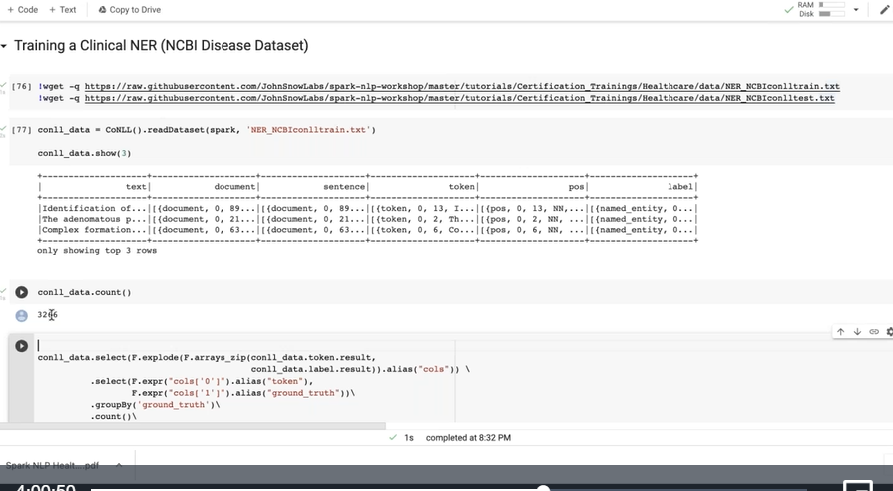

Highly parse

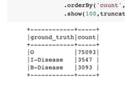

Imbalance prob

--

Why do we need graph

For deep learning

To produce that model should know how many labels

What are embeddings

All info

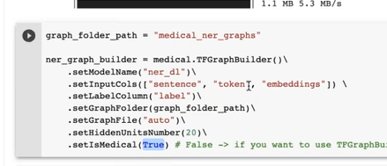

True makes it protected our code

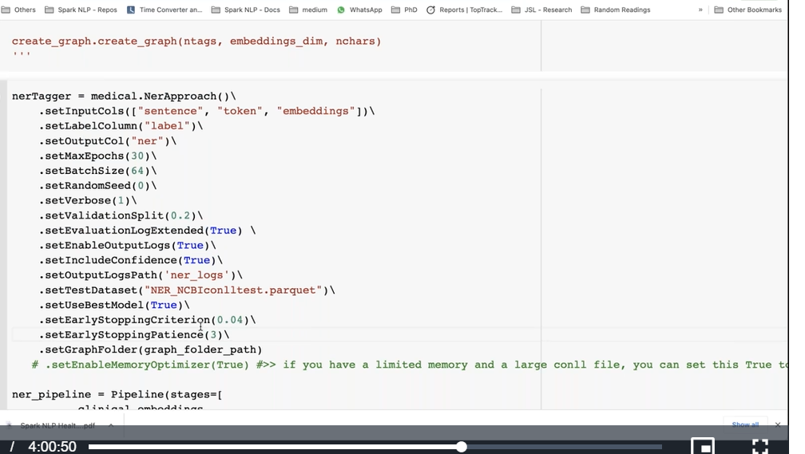

We can fine tune

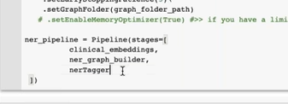

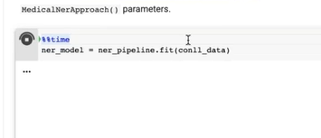

Fit means actual training

--

--

Approach means training

Ner approach means – ner training

--2 approaches;

Full_chunk—gestational diabetic

Partial_chunk – diabatic

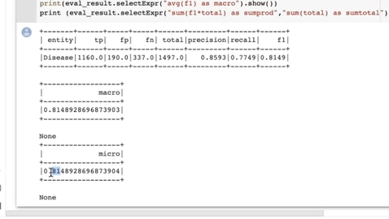

partial chunk’ generate high accuracy

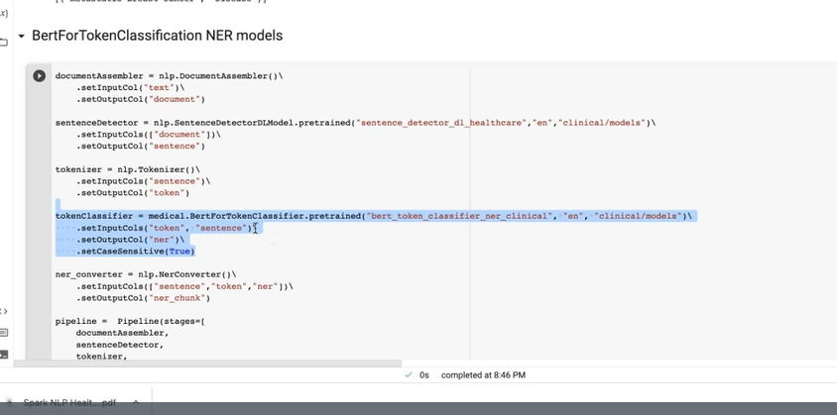

Then we don’t need embedding

Becoz embeddings already in ner

--

What if we don’t know which ner model works better

We can build one pipeline with diff die model stitched together – called ner profiling

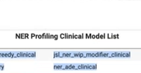

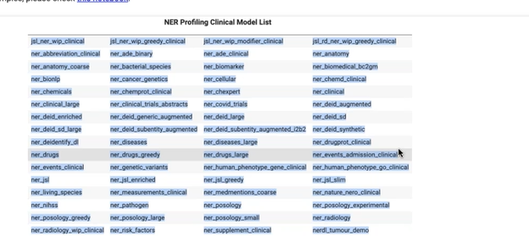

Then take which is useful

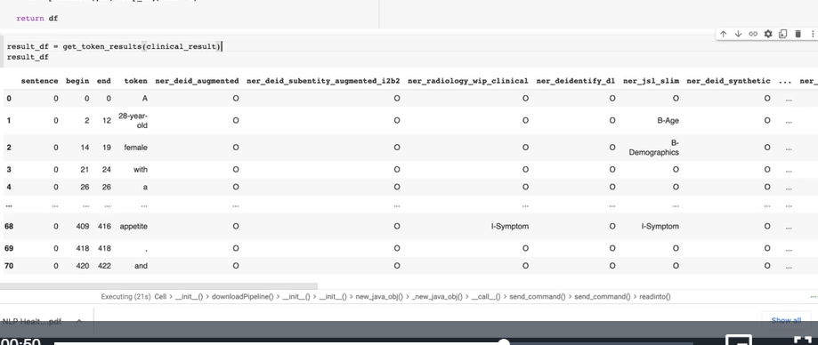

We can able to see which ner is more useful

--

--

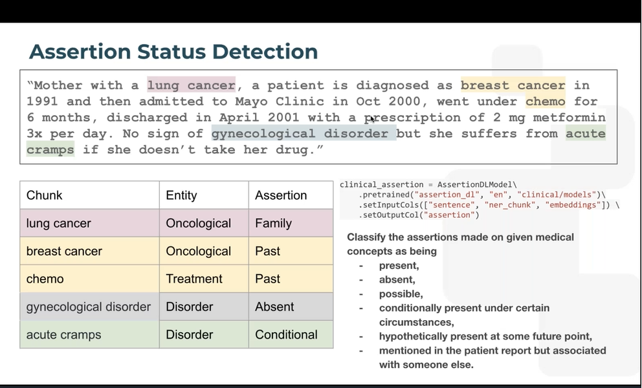

Return give negativity scope

Chucking the chunk

Relation of chunck

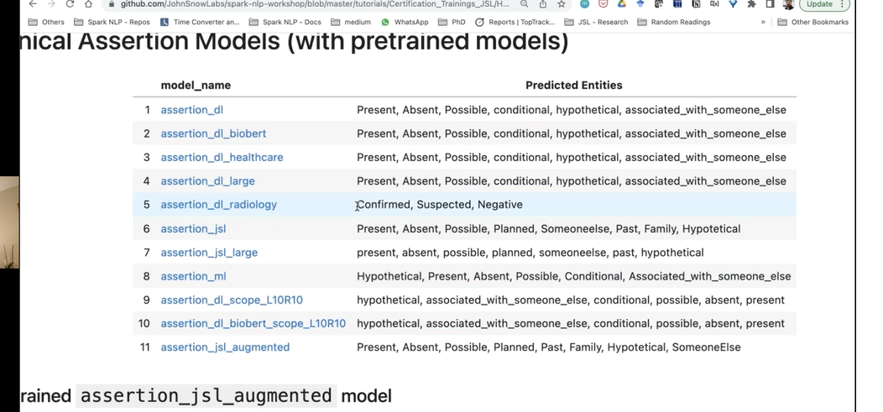

Pipeline till ner converter is same

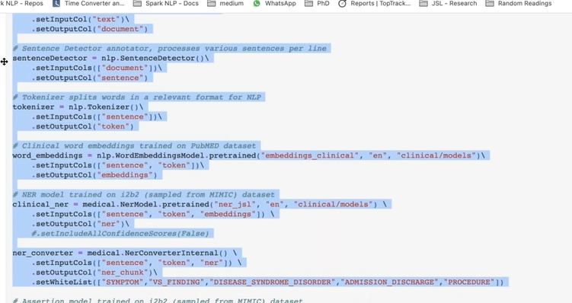

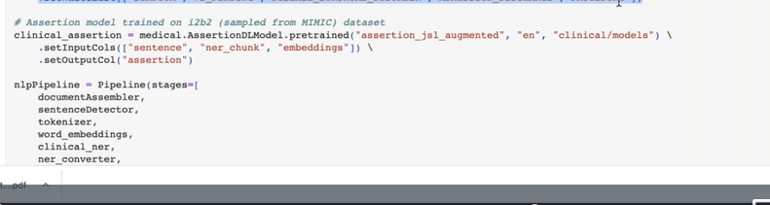

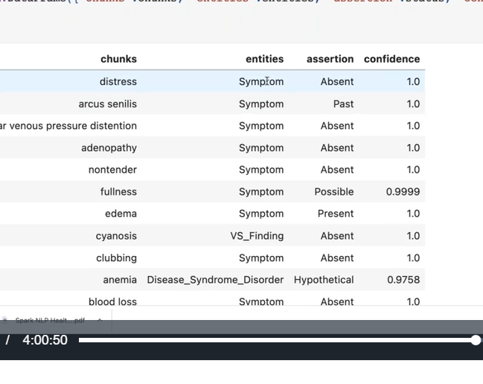

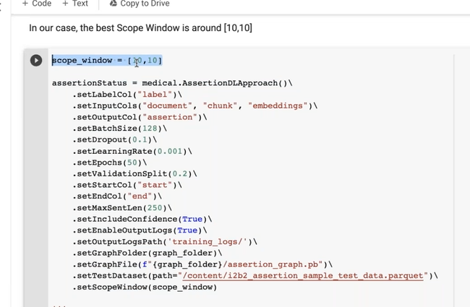

Relation extraction:

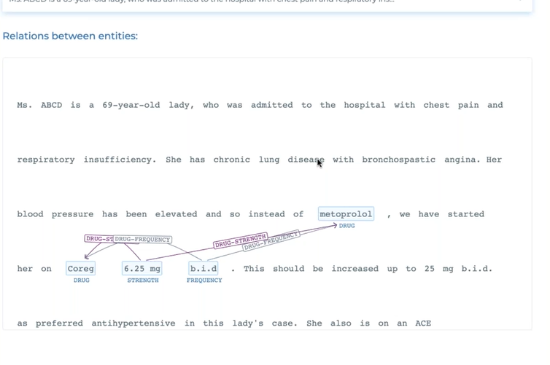

How to link entities together

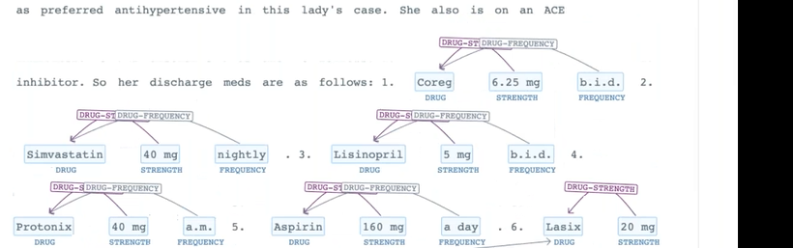

We just get list

But we don’t know their relation

Which drug prescribed for what

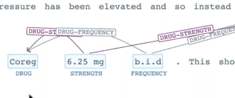

Converting 1D info to others

Related or not related

In complex cases: in what form they are related

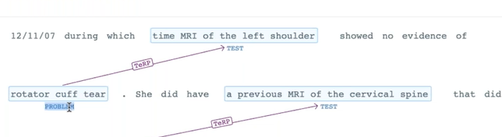

Problem diagnosed the problem?

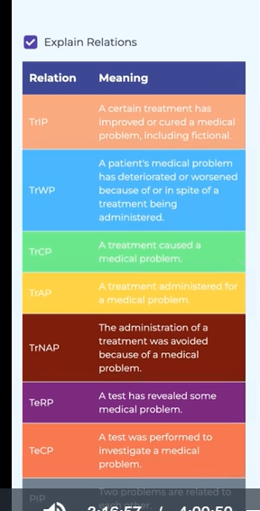

Till ner chunck is same

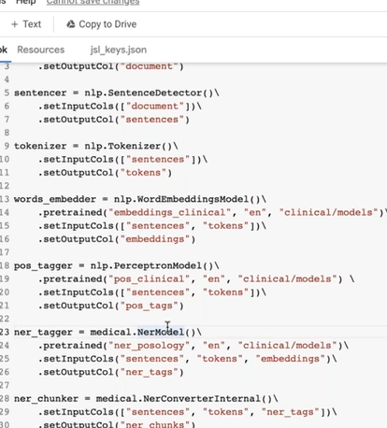

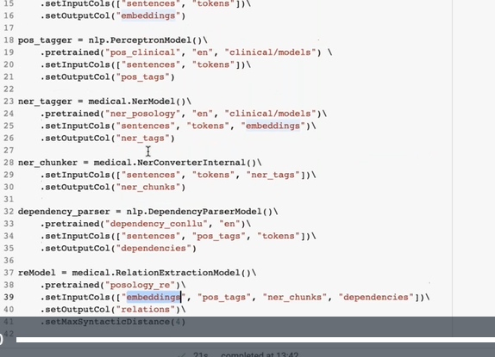

Pos_tag

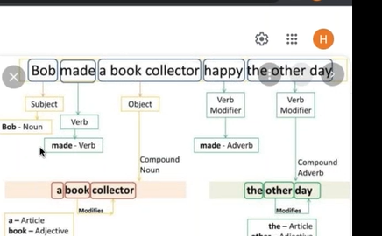

Dependency parsing

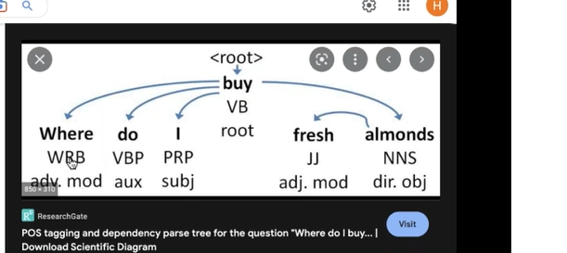

Which token is dependent on which

Linguistic concept

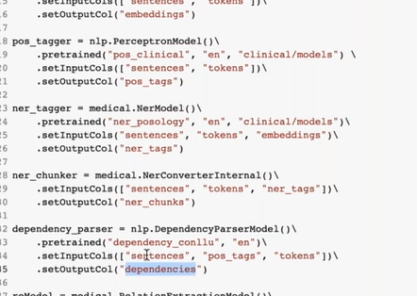

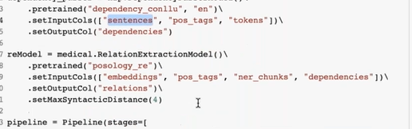

Max syntactic distance:

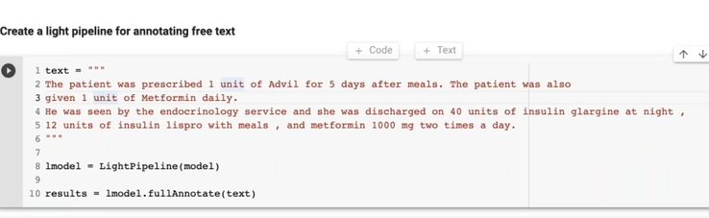

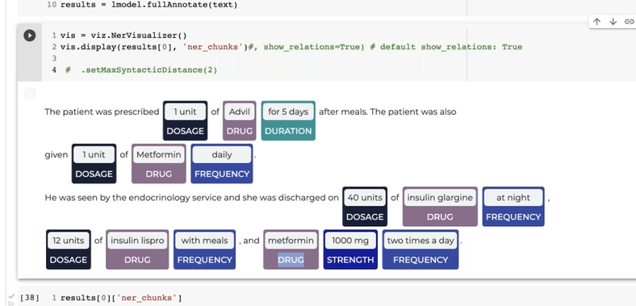

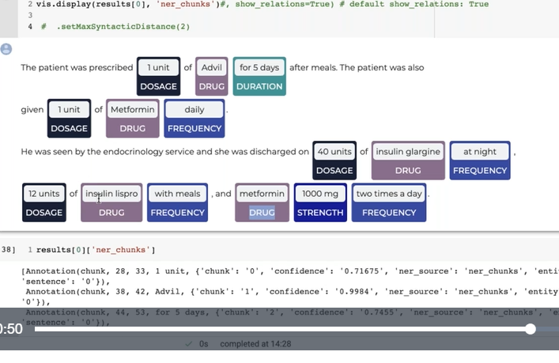

Maxsyntacticdistance= hyper parameter

We can control

2

Take 2 words near

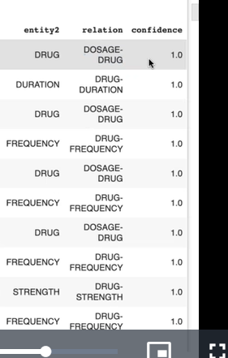

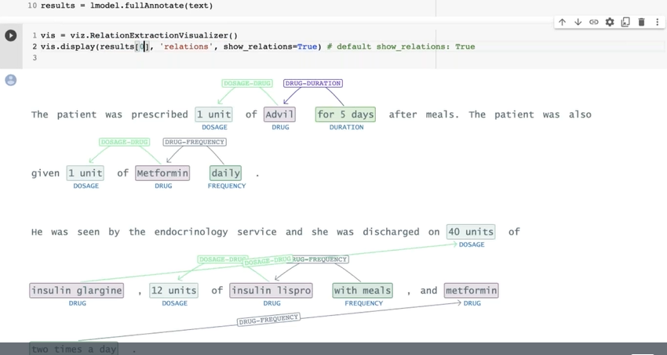

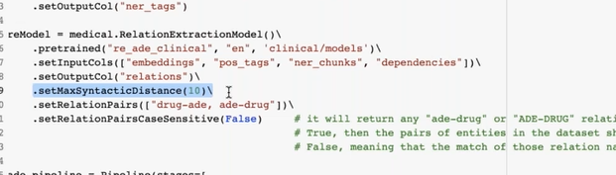

We can control our model

1. How long entity distance
2. Relationship pairs also

* Like this we can prone

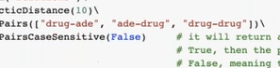

Checking relationship in temporal concepts

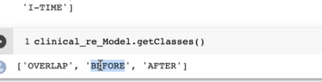

These kind of relation

Problem occurred after entity1

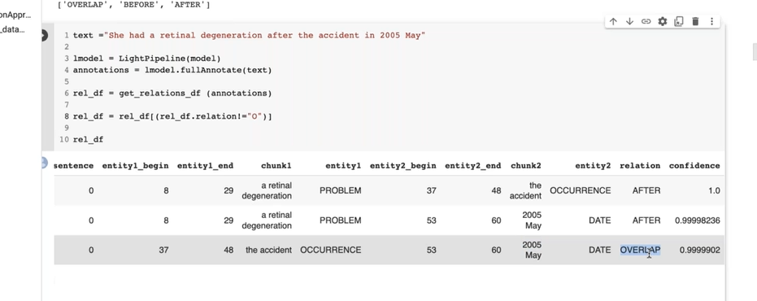

--

Admission discharge model:

--

Pretrained pipelines:

Pip install johnsnowlabs

Upload licence files

Jaison key

Jaison install

Spark session

Take required pipeline

If we use pretained pipelines..

We just send text- get ners or whatever output

--

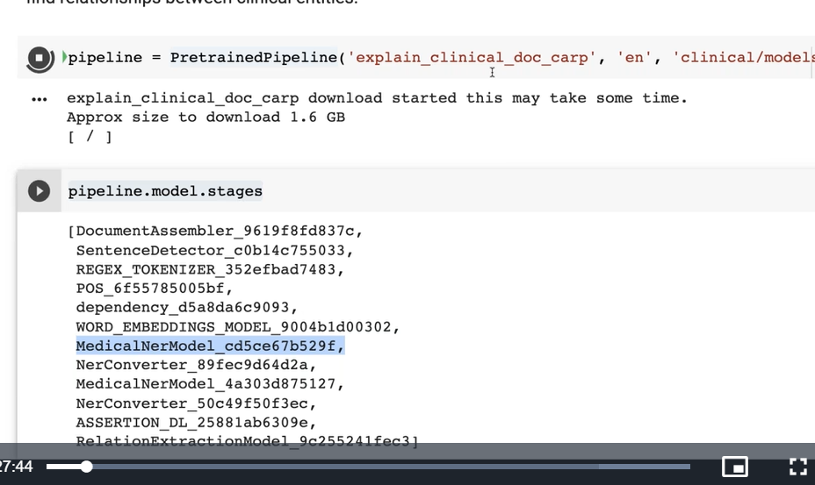

Pretrained pipeline no need to use as light pipeline as it is already light pipeline

We can use either annotate or full annotate

I can also build another pipeline by accessing stages within pretrained

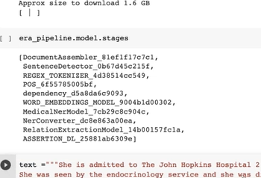

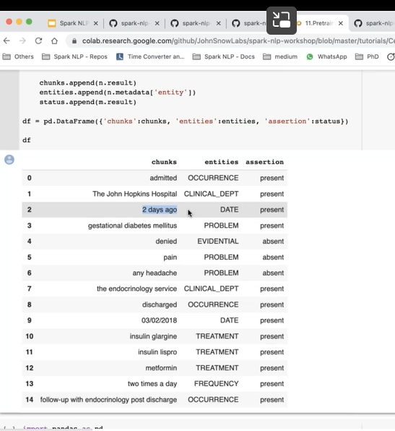

Here date nomalizer didn’t use

If we use data normalizer will give exact date

* 2 days ago
* ---

Adverse drug event:

It’s a health care not clinical

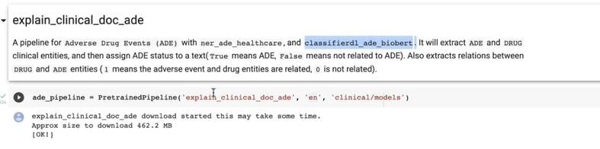

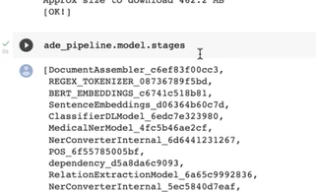

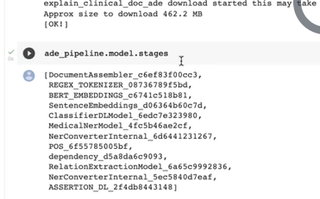

ClassifierDL model

2 classifiers

Multiclasiifiers also there

We didn’t use sentence detector

Used entire statement

Relationship: before, after, overlap

Chunk: our text token

Entity: NER

Ade: adverse drug events

Ner_ade_healthcare model

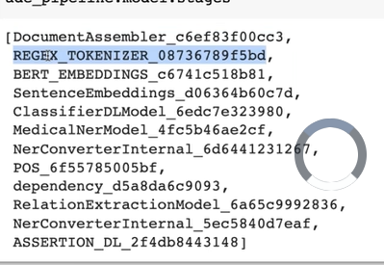

We feed entire document in ade rather than sentence

Filter positive ade documents

We will find entities like adverse drug event and drug entities and their relationship (if both are related)

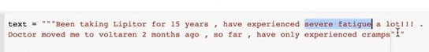

Voltaran – drug

Cramp-symptoms

Liptor- severe fatigue

Relationship

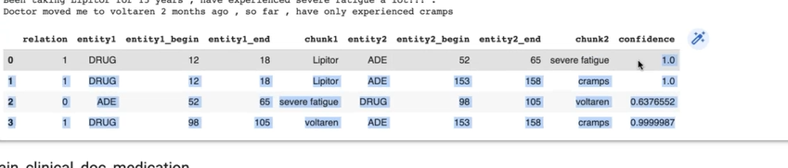

Liptor has no relation with cramps

But it predicted as relationship there – wrong predi- false positive

---\

Clinical medication relation

First find entities

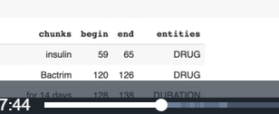

Then assertion

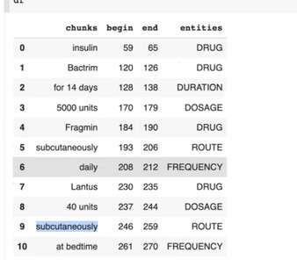

Then find assertion

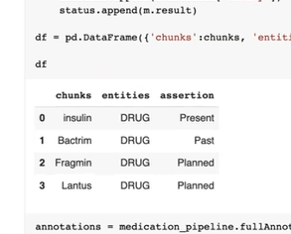

Suspect as assertion means may , not confirmed

Relationship

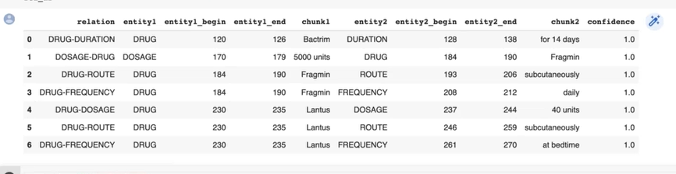

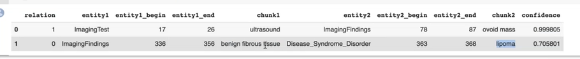

--

deindentification

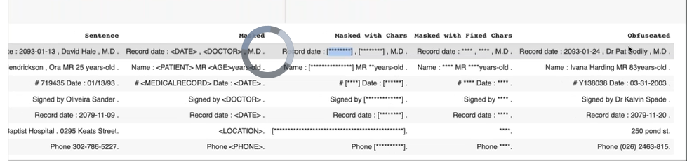

--

Profiling: joint ner models

70 ner models clubbed

To know which ner model best

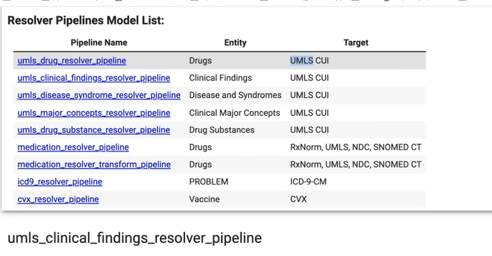

--

Medication resolver pipeline

It give info aboubt medictation – drug -for treatment- ade

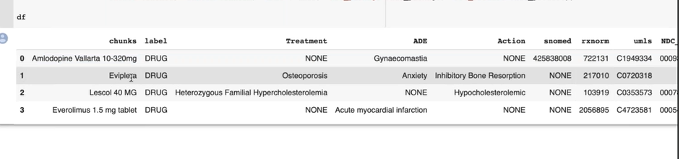

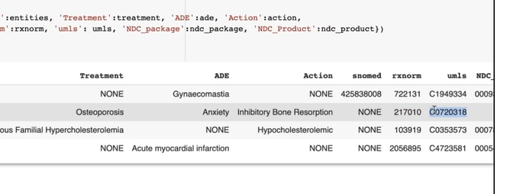

--

Drug normalizer:

If we send this to any resolver it wont find

We need to convert

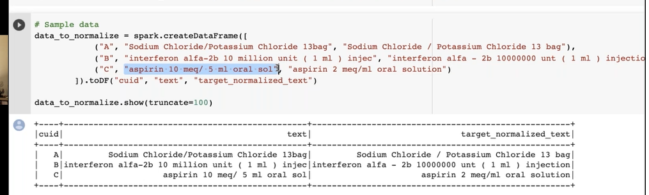

We also have drug spel checker

Drug normalizer accepts only documents

So we club all chunks to doc before normalizer

Neroverwriter:

If mrbrown unrecognized as entity

Then we need to fix

Parkinson -name and disease – we can use chunk merger to detect that

Token level assignment of ner will be done by overwriter

To stitch or resolve the errors

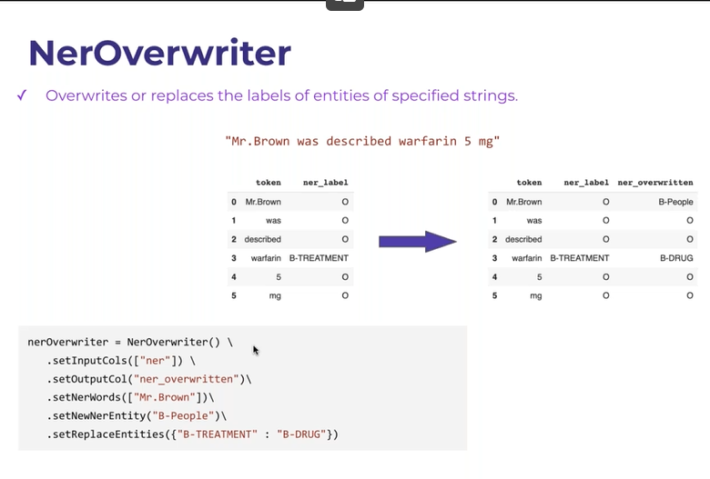

--

Chunk merger: 2 or 5 diff ner model in same pipeline

One token only can get one entity

But when running diff ner model each token will be treated diff by diff ner models

We need to have some rule to merge them to make one lable for token

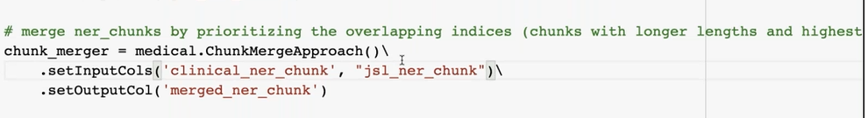

Rule: longer sentence will prevail( if ner predict longer senetese ) that ner entity prevail

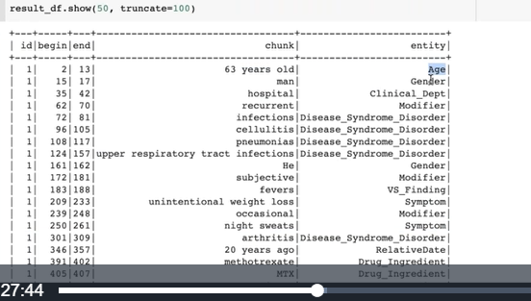

There is no overlapping

If we set overlapping ; overlapping also comes

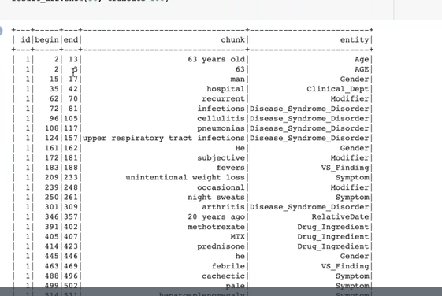

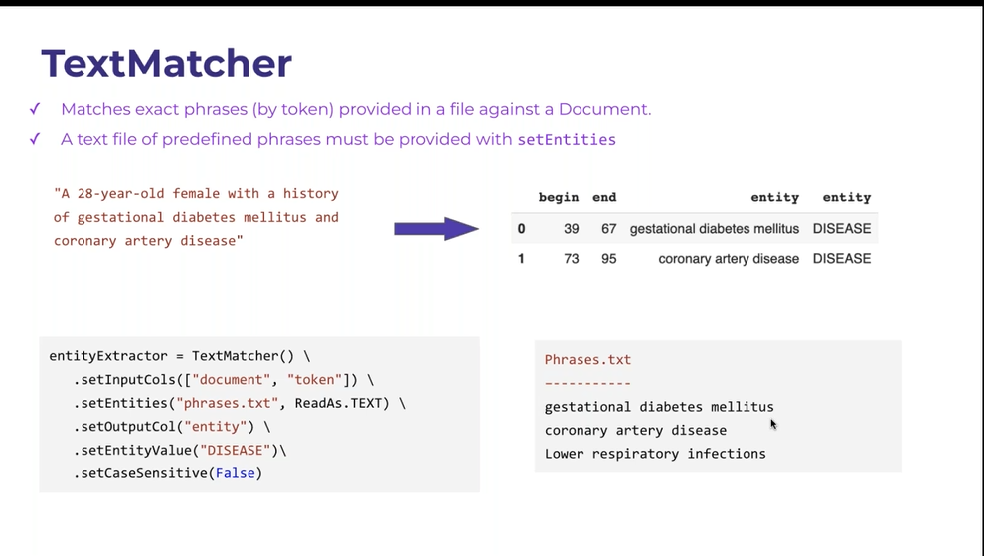

Like rule based ner model

We wil give entities as phases.txt

Contextual parcer:

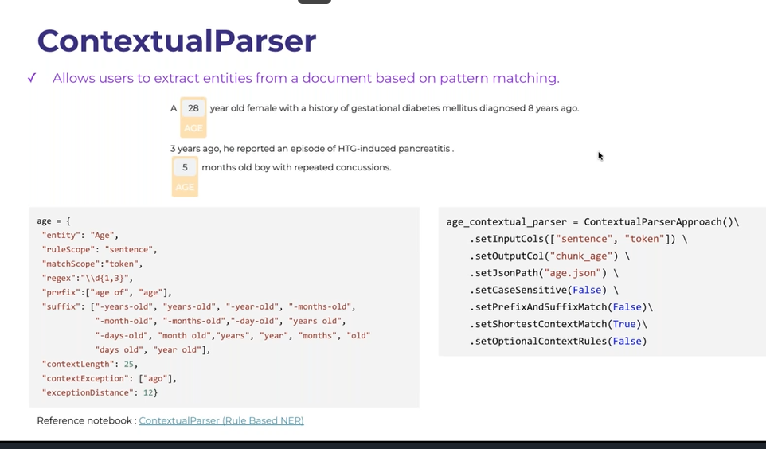

Licenced

We can write many rules

Pattern matching

Different ways to extracting named entities:

Named entity recog

Text matcher

Regexmatcher

Contextual parser

Entity ruler

We can fix

--

Blacklist: block

--

Zero-short named recog:

Question and answer system



What medicine?

Who prescribed?

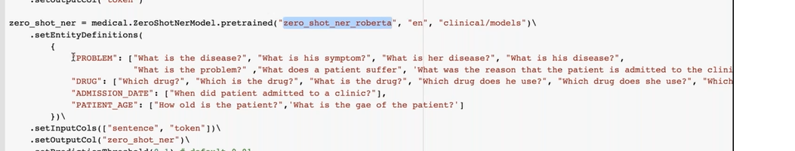

One base model along with questions

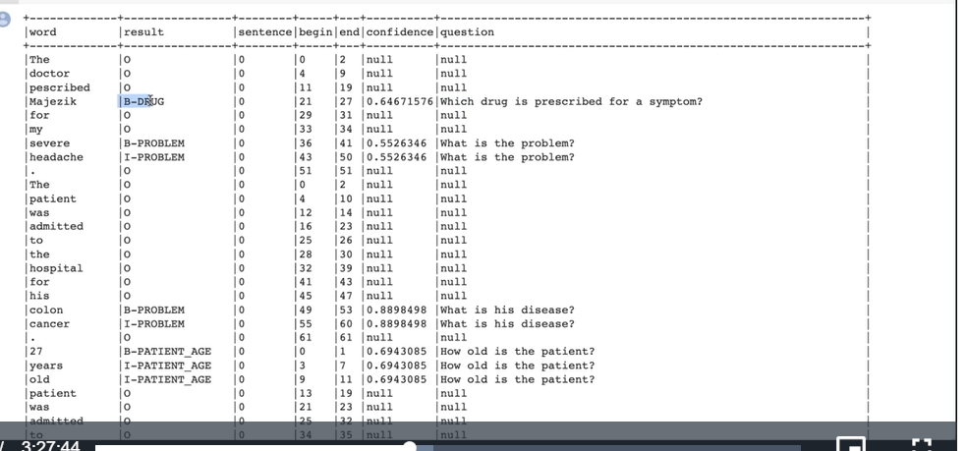

--

Ner question generator

Medicare risk adjustment:

Risk core to certain patients

We need send data

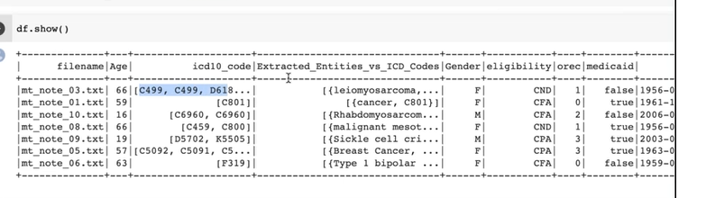

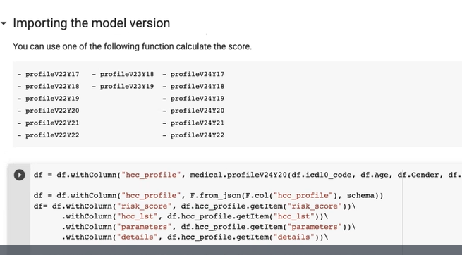

Eligibility criteria

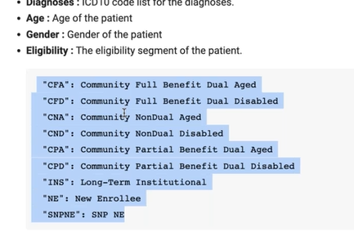

We need to do assertion status also

We should do it only for diseased patients

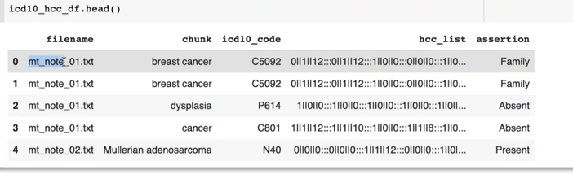

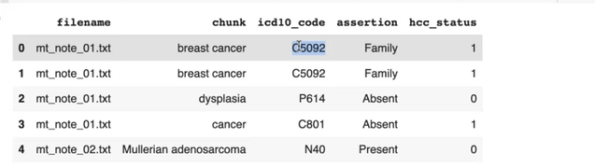

Also used gender classifier

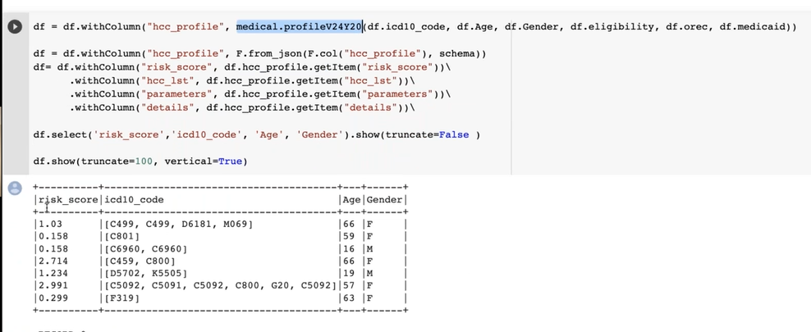

Date normalizer:

2 days ago

3 days ago

If we have clinical data with charge date

First step is findind date

1. Normalizing
2. 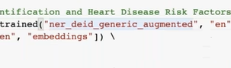

To find date

Then we send output to date normalizer

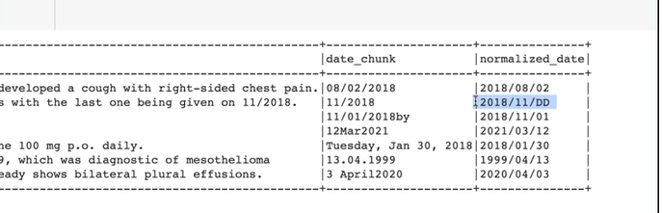

Relative dates : 2 days , 3 days ago – by setting anchor date

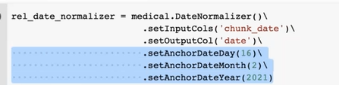

Resume ner model:

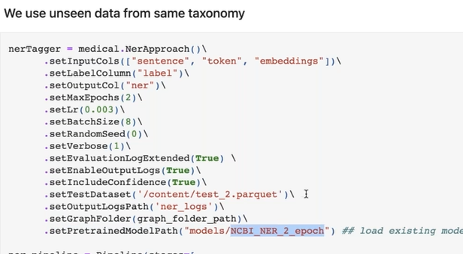

Set pretarained model path

Assertion: looking for left and right of chunk

We can also find long distance

Sentence entity resolvers:

We want codes foe entities

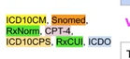

Getting entity is imp for resolver

Picking ner models is imp

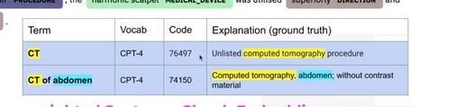

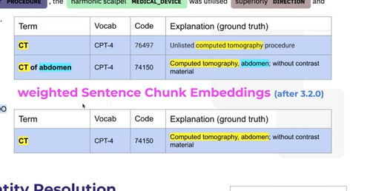

After that we get embeddings

We feed embedings to resolver

It give closest embeddings as a result by resolver models

Revolver model is diff:

Use assertion model

Feed all present entities embedings to resolver- increase speed up

--

We can use more then one resolver models by using : Routers

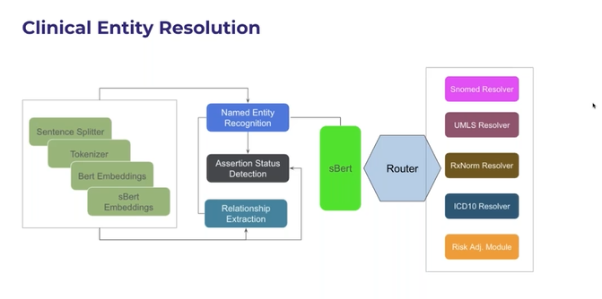

We can get only one chunck

Router filter the entities

Send to relative resolvers –

Confidence score will not use

We use distances

Sentese is mentioned as sentence id

Helper function: get results in a dataframe

--

Resolver model is expensive, high time and memory size

But training reolver model is faster

Parquet file

Expensive part is getting embeddings

That’s y slow

Sol:

Find ners seperatelty

Fit these entities into lighter pipeline of resolvers

First run takes much time

Distance =0 means exact match

Distance not zero means closest match

Drug normalizer- normalized version of drug

--

Chunk map models doent require embeddings

Drug spell checker models

--

Senetese chunk embedding; take sentence embeddings and chunk weights

And return chunk

Resolver still keeps meaning

F